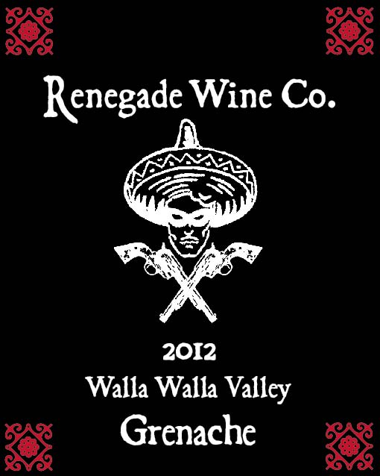

The Renegade Wine Co. is very excited to release the 2012 Renegade Wine Co. Grenache. Only 198 cases of this wine was produced, and after drinking a bottle, you’ll wish we had more! This Grenache, farmed off of the old riverbed in Walla Walla, was barrel aged for 16 months in neutral French oak barrels before bottling. Rarely do you see a single varietal Grenache from Washington, let alone from The Rocks in Walla Walla! Like all the Renegade wines, this drinks as good as something twice as expensive. But you better pick this up soon, as it won’t sit on the shelf long.
Release date March 10th, 2014

